**MINOR PROJECT REPORT**

**On**

**“Real Estate Management System”**

Submitted for the partial fulfilment of the requirement for

Major project work of 5th semester of Bachelor of Computer Application

(BCA) programme.

**Department of Computer Science**

**NERIM GROUP OF INSTITUTIONS**



**Padma Nath Sharma Bhawan, Jayanagar, Guwahati-22**

**Internal Guide Submitted by**

Ms. Chayanika Sharma Sumit Kumar Rai

Assistant Professor BCA 5th semester

Dept. of Computer Science Reg No : 20481124

NERIM Group of Institutions NERIM Group of Institutions

Guwahati Session 2020-23

**CERTIFICATE OF APPROVAL**

This is to certify that the project work entitled “Real Estate Management System” is carried out by Sumit Kumar Rai bearing Examination Roll No: 31620051 , of Dept of Computer Science, NERIM, Guwahati under guidance of Ms. Chayanika Sharma, Asst. Professor, Dept of Computer Science, NERIM, Guwahati has been found satisfactory and is hereby approved as a project work carried out and presented in a manner required for its acceptance in partial fulfilment of course work of 5th semester of 3 year full time BCA under Dibrugarh University, Dibrugarh, Assam.

**Internal Examiner** **External Examiner**

Date: Date:

Place: NERIM, Guwahati

**CERTIFICATE FROM HOD**

This is to certify that the project work entitled “Real Estate Management System” is carried out by Sumit Kumar Rai bearing University Registration No: 20481124 and Roll Number: 31620051 , of NERIM and Internal guidance of Ms. Chayanika Sharma, in partial fulfilment of minor project work of 5th semester of 3 years full time BCA course under Dibrugarh University, Dibrugarh, Assam is accepted by the Department of Computer Science, NERIM, Guwahati.

Dr. Hillol Kanti Bhattacharjee Date:

HOD, Dept of Computer Science

NERIM Group of Institutions

Guwahati, Assam

**CERTIFICATE FROM INTERNAL GUIDE**

This is to certify that the project work entitled “Real Estate Management System” is a bonafide work carried out by Sumit Kumar Rai of BCA 5th semester of 3 years full time BCA course under Dibrugarh University at NERIM, Guwahati, bearing Examination Roll Number: 31620051 , under my personal supervision and guidance. The report is found worthy of acceptance for the partial fulfilment of major project work of BCA 5th semester under 3 year full time BCA program under Dibrugarh University, Dibrugarh, Assam.

All help received has been duly acknowledged and no part of this report has been reproduced for any other degree or diploma.

Ms. Chayanika Sharma Date

Asst. Professor, Dept of Computer Science

NERIM Group of Institutions

Guwahati, Assam

**ACKNOWLEDGEMENT**

At the very inception I would like to take the privilege to thank the name of the organisation head with the organisation name in course of undergoing my project.

I would like to thank Dr. Hillol Kanti Bhattacharjee, HOD, Computer Science Department, NERIM Group of Institutions for his valuable suggestions.

With immense pleasure I acknowledge my inertness to all persons whose support and guidance have helped me in carrying out this project.

Also, I acknowledge most sincerely my heartiest thanks and gratitude to my internal guide Ms. Chayanika Sharma who has guided me throughout the period of this project work.

To those mentioned above and to those who inspired and encouraged me, I would like to express my gratitude once again.

**With regards**

Sumit Kumar Rai

Examination Roll No:31620051

BCA 5th semester

**DECLARATION**

I hereby declare that the project work called “**Real Estate Management System**” submitted to the Computer Science Department of NERIM, Guwahati under Dibrugarh University is a record of an original work done by me under the guidance of “**Ms. Chayanika Sharma**” and this project is submitted for the partial fulfilment of the degree of Bachelors of Computer Application under Dibrugarh University, Dibrugarh, Assam. The results embodied in this, have not been submitted to any other University or Institute.

**With regards**

Sumit Kumar Rai

Examination No: 31620051

BCA 5th semester

**CONTENTS**

**Chapter 1; INTRODUCTION**

1.1 TITLE OF THE PROJECT

1.2 PROJECT DEFINITION

1.3 OBJECTIVE

1.4 ADVANTAGES OF PROPOSED SYSTEM OVER EXISTING SYSTEM

1.5 HARDWARE AND SOFTWARE

**Chapter 2: SYSTEM ANALYSIS**

2.1 INTRODUCTION

2.2 FEASIBILITY STUDY

2.2.1 INTRODUCTION

2.2.2 ECONOMIC FEASIBILITY

2.2.3 TECHNICAL FEASIBILITY

2.2.4 BEHAVIOURAL FEASIBILITY

2.3 SYSTEM REQUIREMENT GATHERING AND ANALYSIS

2.4 STRUCTURED ANALYSIS AND DESIGN

2.4.1 DFD

2.4.2 DATA DICTIONARY

2.4.3 ER DIAGRAM

2.4.4 DATABASE DESIGN

**Chapter 3: FRONT END DESIGN**

3.1 INPUT DESIGN

**Chapter 4: TESTING**

4.1 UNIT TESTING

4.2 INTEGRATION TESTING

4.3 USER ACCEPTANCE TESTING

**Chapter 5: FUTURE SCOPE OF THE PROJECT**

**CONCLUSION**

**BIBLIOGRAPHY**

**CHAPTER 1: INTRODUCTION**

* 1. **TITLE OF THE PROJECT**

**“Real Estate Management System”**

**1.2 PROJECT DEFINITION**

Real Estate (property) Management system is developed for those who are searching property according to their criteria or nearby location. Seller can post their property on the website with complete details about property and contact information. Buyers visit this website, look property and if they like any property they can contact seller through the given number or email ID.

**1.3 OBJECTIVE**

The objective of this system is as follows:

* Admin get access to all data stored.
* The system is user friendly.
* Aims to provide a system which can store records systematically.
* Shows the information and description of the properties available.
* Updating ,Adding of records is improved which result in proper resource management of properties data

**1.4 ADVANTAGES OF PROPOSED SYSTEM**

⦁ There are less chances of error.

⦁ The system is very easy to use.

⦁ Ease in modifications.

⦁ Providing a less complex and more user friendly environment.

**PROPOSED SYSTEM** : The proposed System puts emphasis on efficiency and less labour. The application will help seller to list their property systematically so they can easily get buyers. Any change in the database can easily be tracked .

**1.5 HARDWARE AND SOFTWARE**

**HARDWARE SPECIFICATION**

PROCESSOR : Intel core i3

RAM: 1 GB or more

HARD DISK : 20 GB or more.

KEYBOARD : Standard.

MOUSE : Optical

**SOFTWARE SPECIFICATION**

OPERATING SYSTEM : Windows 7 or better

SERVER : XAMPP

FRONT END : HTML, CSS, JavaScript

Back End : MySQL, PHP

DATABASE : MySQL

**CHAPTER 2: SYSTEM ANALYSIS**

**2.1 INTRODUCTION**

System analysis is conducted for the purpose of studying a system or its parts in order to identify its objectives. It is a problem solving technique that improves the system and ensures that all the components of the system work efficiently to accomplish their purpose. It is a process of collecting and interpreting facts, identifying the problems, and decomposition of a system into its components. Analysis specifies what the system should do.

**2.2 FEASIBILITY STUDY**

**2.2.1 INTRODUCTION**

Feasibility is defined as the practice extent to which a project can be performed successfully. To evaluate feasibility, a feasibility study is performed, which determines whether the solution considered to accomplish the requirements is practical and workable in the software. The objective of the feasibility study is to establish the reasons for developing the software that is acceptable to users, adaptable to change and comfortable to establish standards.

**2.2.2 ECONOMIC FEASIBILITY**

Economic feasibility looks at the financial aspects of the project. It is the most frequently used technique for evaluating the effectiveness of a proposed system. Economic feasibility is more commonly known as cost/benefit analysis. The procedure is to determine the benefits and savings that are expected from a proposed system and compare them with cost. It benefits outweighs costs, a decision is taken to design and implement the system. Otherwise, further justification.

The proposed system is economically feasible because

⦁ The cost of the hardware is affordable as it is built on my laptop.

⦁ All the software’s used were available for free

**2.2.3 TECHNICAL FEASIBILIT**Y

The technical feasibility assessment is focused on gaining and understanding of the present technical resources of the organisation and their applicability to the expected needs of the proposed system. It is the evaluation of the hardware and software and how it meets the needs of the proposed system.

The **Real Estate Management System** is technically feasible because

⦁ To run the software comparatively very less amount of resources is required such as hardware required are monitor, a CPU with minimal amount of RAM; and software such as: a web browser, windows operating system.

**2.2.4 BEHAVIOURAL FEASIBILITY**

The proposed system behaves as expected and to test the input, SRS cases have been tested and validated.

**2.3 SOFTWARE REQUIREMENT GATHERING AND SPECIFICATION**

Requirement is a condition or capability possessed by the software or system component in order to solve real world problems. It describes how a system should act, appear or perform. Requirements help to understand the behaviour of a system, which is described by various tasks of the system.

The final stage of the analysis phase is to develop the software requirements and specification document. After gathering the requirements from the user or client, with the help of some tools, the gathered requirements are thoroughly analysed and accordingly the SRS document is prepared.

**FUNCTIONAL REQUIREMENTS**

⦁ Admin can login into the system using username and password.

⦁ Admin can add, update, delete the information of the property.

⦁ Admin can sell the property.

**NON – FUNCTIONAL REQUIREMENTS**

⦁ The system should have a high response time.

⦁ It should be easy for the admin to use the system.

**SRS For Admin**

|  |  |  |  |
| --- | --- | --- | --- |
| **Sl No** | **Requirement Name** | **Requirement Description** | **Priority** |
| SRS001 | Log in | This function will enable the admin to login into the system by providing a valid username and password | Mandatory requirement |
| SRS001.1* | Log in | If found valid then the system will direct the admin to the dashboard | Mandatory requirement |
| SRS001.2* | Log in | If found invalid the system will say invalid username or password | Mandatory requirement |
| SRS002 | Insert Details | Admin can add property details | Mandatory requirement |
| SRS003 | View Details | Admin can view property details | Mandatory requirement |
| SRS004 | Delete Details | Admin can update property details | Mandatory requirement |
| SSRS005 | Update Details | Admin can update property details | Mandatory requirement |

**SRS For User**

|  |  |  |  |
| --- | --- | --- | --- |
| **Sl No** | **Requirement Name** | **Requirement Description** | **Priority** |
| SRS001 | Register | This function will enable the user to login into the system by providing a valid username and password | Mandatory requirement |
| SRS002 | Login | If found valid then the system will direct the user to the Homepage | Mandatory requirement |
| SRS003 | Login | If found invalid the system will say invalid username or password | Mandatory requirement |

**2.4 STRUCTURED ANALYSIS AND DESIGN**

**2.4.1 DATA FLOW DIAGRAM**

A data flow diagram (or DFD) is a graphically representation of the flow of data through an information system. It shows how information is input to and output from the system, the sources and destinations of that information, and where that information is stored.

**The following diagram diagrams illustrate notation and symbol used to construct DFD :**

External Entity

A process

Data Flow

Data Storage

A report or output from system

**CONTEXT DIAGRAM**

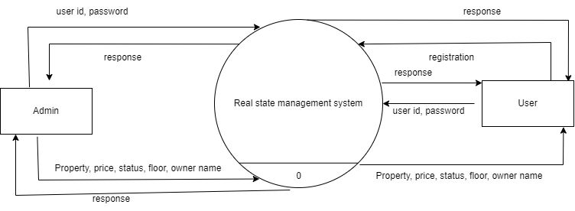

**DFD LEVEL 1 FOR ADMIN**

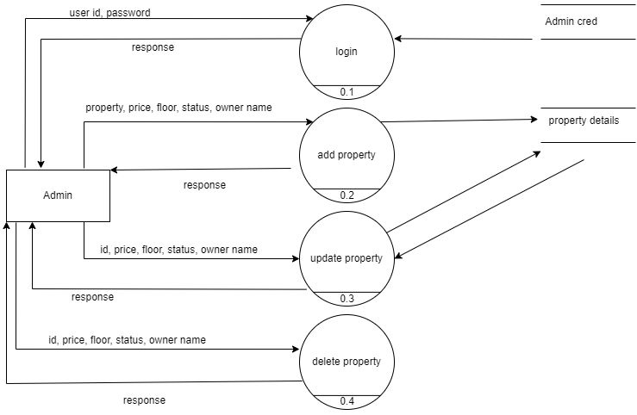

**DFD LEVEL 1 FOR USER**

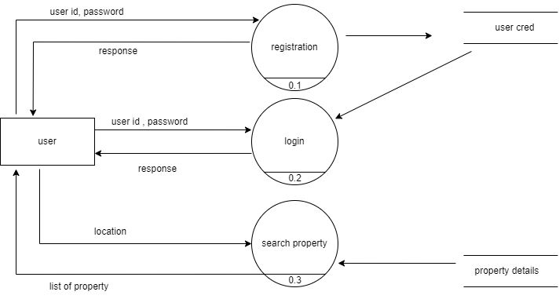

**2.4.2 DATA DICTIONARY**

A data dictionary contains metadata that is data about the database. The data dictionary is very important as it contains information such as what is in the database, who is allowed to access it, where is the database physically stored etc. The users of the database normally don’t interact with the data dictionary, it is only handled by the database administrators.

|  |  |  |  |  |
| --- | --- | --- | --- | --- |
| **SL NO** | **FIELD NAME** | **DATA TYPE** | **SIZE** | **DESCRIPTION** |
| 1 | username | varchar | 50 | Admin username |
| 2 | password | varchar | 50 | Admin password |
| 3 | username | Varchar | 50 | User username |
| 4 | password | varchar | 50 | User password |
| 5 | name | varchar | 100 | Owner name |
| 6 | monthly | varchar | 100 | Price details |
| 7 | Address | varchar | 255 | Address details |
| 8 | Contact_no | varchar | 100 | Contact details |
| 9 | Floor | Varchar | 100 | Floor details |
| 10 | utility | Varchar | 100 | Current status |
| 11 | Descrip | Text | 100 | Description about the property |
| 12 | images | varchar | 255 | House images |
| 13 | proid | varchar | 100 | Room images |

**2.4.3 ENTITY RELATIONSHIP DIAGRAM**

Entity relationship diagram is a popular high level conceptual data model. This model and its variation are frequently used for the conceptual design of the database application and many database design tools employ its concepts.

The ER diagram describes data as entities, relationship and attributes:

**Entities** : The basic object that the ER model represents is an entity which is a thing in the real world with an independent existence. An entity may be an object with a physical existence.

**Attribute** : Each entity has attributes, the particular properties that describe it. The attributes values that describe each entity become a major part of the data stored in the database.

**Relationship** : There are several implicit relationships among the various entity types. In fact, whenever an attribute of one entity refers to another entity type, some relationship exists. The degree of relationship type is the number of participating entity types. A relationship type of degree two is called binary and one of degree three is called ternary.

**Cardinality Ratio** : The cardinality ratio for a binary relationship specifies the maximum number of relationship instances that an entity can participate in. The possible cardinality ratios for binary types are 1:1, 1: N and M: N.

**The following diagram diagrams illustrate notation and symbols used to construct ER Diagram**.

External entity

Attribute

Relationship

**ER DIAGRAM**

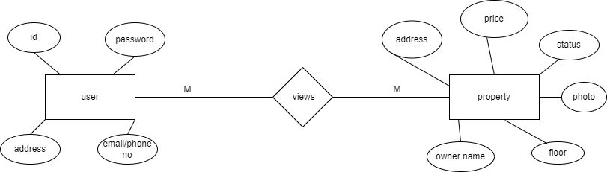

**2.4.4 DATABASE DESIGN**

Database design is a data flow based methodology. The approach begins with a new system specification that identifies inputs and outputs and describes the functional aspects of the system. The specification then is used as a basis for the graphical representation

**Images Table**

|  |  |  |  |
| --- | --- | --- | --- |
| **Field** | **Data type** | **Size** | **Constraints** |
| Id | int | 11 | Primary key |
| Images | varchar | 255 |  |
| Proid | varchar | 100 |  |

**Login Table**

|  |  |  |  |
| --- | --- | --- | --- |
| **Field** | **Data type** | **Size** | **Constraints** |
| Id | int | 11 | Primary key |
| username | varchar | 100 |  |
| Password | varchar | 100 |  |

**Property Table**

|  |  |  |  |
| --- | --- | --- | --- |
| **Field** | **Data type** | **Size** | **Constraints** |
| Id | int | 11 | Primary key |
| name | varchar | 255 |  |
| monthly | varchar | 100 |  |
| Address | varchar | 255 |  |
| Contact_no | varchar | 100 |  |
| Floor | Varchar | 100 |  |
| utility | Varchar | 100 |  |
| Descrip | Text | 100 |  |
| images | varchar | 255 |  |

**CHAPTER 3: FRONT-END DESIGN**

**3.1 INPUT DESIGN**

Input design is the process of converting user-oriented inputs to a computer-based formal. The goal is to make the data entry as easy, logical and free from errors as possible. Once the analysis and design of the system has been done, it would be necessary on the part of the programmer to determine and identify the data that are required to be processed to produce the desired results or outputs. Input is one of the most expensive phases of the operations of a computerised system and sometimes creates a major problem. Different types of problems with a system can usually be traced back to faulty input design methods. The input design can also determine whether the user can interact efficiently with the system.

**LOGIN PAGE**



**ADMIN HOME-PAGE**

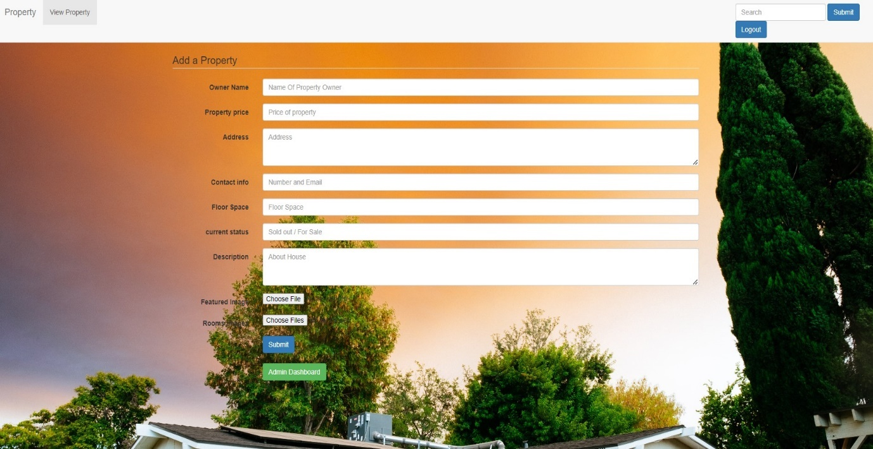

**ADMIN DASHBOARD**

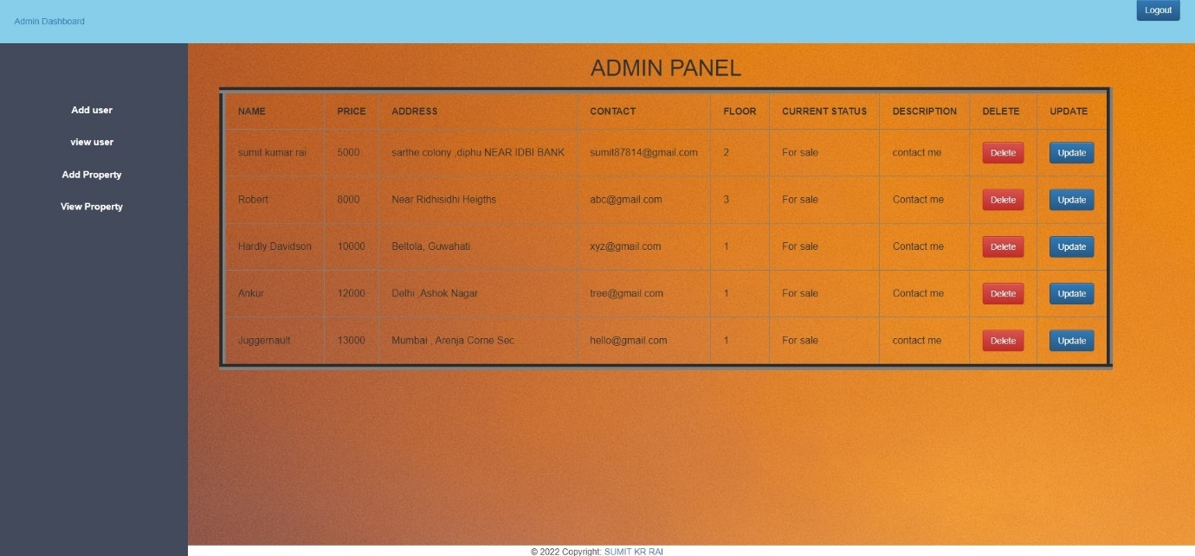

**USER HOME-PAGE**

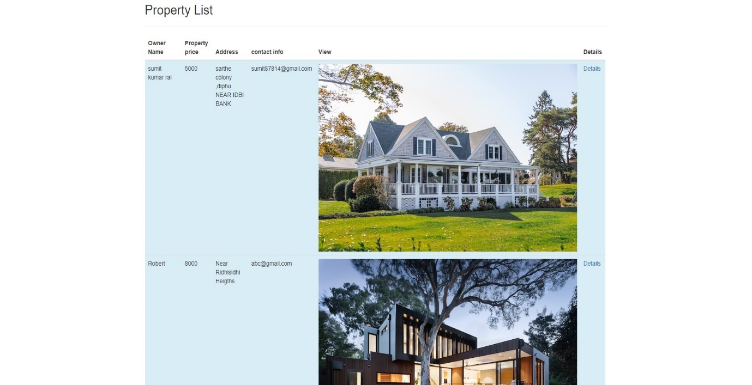

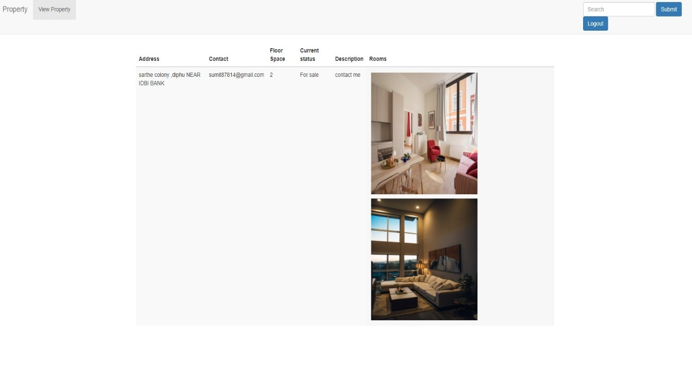

**4.1 Unit Testing**

Unit testing involves the testing of each unit or an individual component of the software application. It is the first level of functional testing. The aim behind unit testing is to validate unit components with its performance. However, it is possible that the outputs produced by one unit test become input for another unit. Hence, if incorrect output produced by one unit is provided as input to the next unit then it also produces wrong output. If this process is not corrected, the entire software may produce unexpected outputs. To avoid this, all units in the software are tested independently using unit testing. The log in function will enable the administrator to log in to the system by providing a valid user-id and password.

**For Admin**

|  |  |  |  |
| --- | --- | --- | --- |
| **SL No** | **Process** | **Test Case** | **Action** |
| SRS001 | Log in | If the admin tries to log in using empty Username or password | There will be an alert “Please enter your Username or password”. |
| SRS001.1 | Log in | If the admin tries to log in using invalid Username | There will be an alert “Invalid Username” |
| SRS001.2 | Log in | If the admin tries to log in using invalid Password | There will be an alert “Invalid Password” |

**For Adding Property**

**Through Submit admin can add new property to the system.**

| **SL No** | **Process** | **Test Case** | **Action** |
| --- | --- | --- | --- |
| SRS001 | Submit | On clicking submit button | New property will be added to the system |
| SRS001.1 | Name | If the admin tries to enter empty Name | There will be an alert “This field cannot be empty” |
| SRS001.2 | Monthly | If the admin tries to enter empty Monthly | There will be an alert “This field cannot be empty” |
| SRS001.3 | Address | If the admin tries to enter empty Address | There will be an alert “This field cannot be empty” |
| SRS001.4 | Contact_no | If the admin tries to enter empty Contact_no | There will be an alert “This field cannot be empty” |
| SRS001.5 | Floor | If the admin tries to enter empty Floor | There will be an alert “This field cannot be empty” |
| SRS001.6 | utility | If the admin tries to enter empty Utility | There will be an alert “This field cannot be empty” |
| SRS001.7 | Descrip | If the admin tries to enter empty Descrip | There will be an alert “This field cannot be empty” |

**Through ADMIN DASHBOARD admin can view the property details from the system.**

|  |  |  |  |
| --- | --- | --- | --- |
| **SL No** | **Process** | **Test Case** | **Action** |
| SRS002 | Admin Dashboard | If the admin clicks on Admin Dashboard | There will be a table showing all the details of the property |

**Through UPDATE admin can update Property details.**

|  |  |  |  |
| --- | --- | --- | --- |
| **SL No** | **Process** | **Test Case** | **Action** |
| SRS003 | Update | If the admin clicks on submit after editing the required fields | There will be an alert showing “Property Updated” |

**Through DELETE admin can delete Property details.**

|  |  |  |  |
| --- | --- | --- | --- |
| **SL No** | **Process** | **Test Case** | **Action** |
| SRS004 | Delete | If the admin clicks on delete | There will be an alert showing “Are you sure you want to delete” |

**For User**

|  |  |  |  |
| --- | --- | --- | --- |
| **SL No** | **Process** | **Test Case** | **Action** |
| SRS001 | Log in | If the user tries to log in using empty Username or password | There will be an alert “Please enter your Username or password”. |
| SRS001.1 | Log in | If the user tries to log in using invalid Username | There will be an alert “Invalid Username” |
| SRS001.2 | Log in | If the user tries to log in using invalid Password | There will be an alert “Invalid Password” |

**Through View Property user can view properties that are listed in the system.**

|  |  |  |  |
| --- | --- | --- | --- |
| **SL No** | **Process** | **Test Case** | **Action** |
| SRS002 | View Property | If the user clicks on view property | There will be a table showing all the details of the listed properties |

**4.2 INTEGRATION TESTING**

Once unit testing is complete, integration testing begins. In integration testing, the units validated during unit testing are combined to form a subsystem. The integration testing is aimed at ensuring that all the modules work properly as per the user requirement when they are put together that is integrated.

**ADMIN**

|  |  |  |
| --- | --- | --- |
| **SERIAL NUMBER** | **MODULE 1** | **MODULE 2** |
| 1 | If not logged into the system | Cannot go to the dashboard |
| 2 | If not logged into the system | Cannot add property |
| 3 | If not logged into the system | Cannot view property |
| 4 | If not logged into the system | Cannot update property |
| 5 | If not logged into the system | Cannot delete property |

**USER**

|  |  |  |
| --- | --- | --- |
| **SERIAL NUMBER** | **MODULE 1** | **MODULE 2** |
| 1 | If not logged into the system | Cannot go to the Homepage |
| 2 | If not logged into the system | Cannot view property |

**4.3 USER ACCEPTANCE TESTING**

Acceptance testing is performed to ensure that the functional, behavioural and performance requirements of the software are met. IEEE defines acceptance testing as a formal testing with respect to user needs, requirements and business process conducted to determine whether or not a system satisfies the acceptance criteria and to enable the user, customers or other authorised entity to determine whether or not to accept the system.

**CHAPTER 5 : FUTURE SCOPE OF THE PROJECT**

The future scope of the project includes what all future enhancements can be done in this system to make it more feasible to use. While developing the software, though we have tried our best to fulfil all necessities of the organisation, there is every possibility of some drawbacks in the software. Those drawbacks can be overcome by further modifying the system by allowing user to login the system and add property themselves to sell to other buyers Again the rest of the need is to change its appearance so that it becomes more user friendly.

Some of the extensions which can be made later are:

1. More graphics can be added to make it more user friendly and understandable.
2. Chatting options can be added for better communication
3. Allowing user to list their own property

**CONCLUSION**

While developing the system a conscious effort has been made to create and develop a software package, making use of available tools, techniques and resources – that would generate a proper system. While making the system , an eye has been kept on making it as user-friendly, as cost-effective and as flexible as possible. As such one may hope that the system will be acceptable to any user and will adequately meet his/her requirements.

Working on this project was a good experience. It taught how important every step is in developing software, from collecting user requirements to planning and giving proper coding to every design.

**BIBLIOGRAPHY**

BOOKS REFERRED:

* Mall, R. (2009). *Fundamentals of Software Engineering,* 3rd Edition,PHI Learning Private Limited, pp. 114-116, 172-196.
* Elmasri, R., Navathe, S.B. (2012). *Fundamentals of Database Systems*, 5th Edition, Pearson. pp. 60- 79.

WEB SITES:

* <https://www.w3schools.com/php/default.asp>
* <https://dev.mysql.com/doc/>
* <https://www.guru99.com/er-diagram-tutorial-dbms.html>
* https://youtu.be/AVS0wm5wohc